
American International University-Bangladesh (AIUB)
Faculty of Engineering
Department of CSE, EEE, and CoE

EEE4103 MICROPROCESSOR AND EMBEDDED SYSTEM
COURSE CAPSTONE PROJECT PROPOSAL FORM

SEMESTER: SUMMER 2025-26
PROJECT TITLE: Adaptive Threshold-Based Smart Temperature Monitoring and Control System Using ESP32 and Mobile IoT Interface
SURVEY :

Survey link : https://forms.gle/2agbdiaDxFC6jKUX8

Questions :

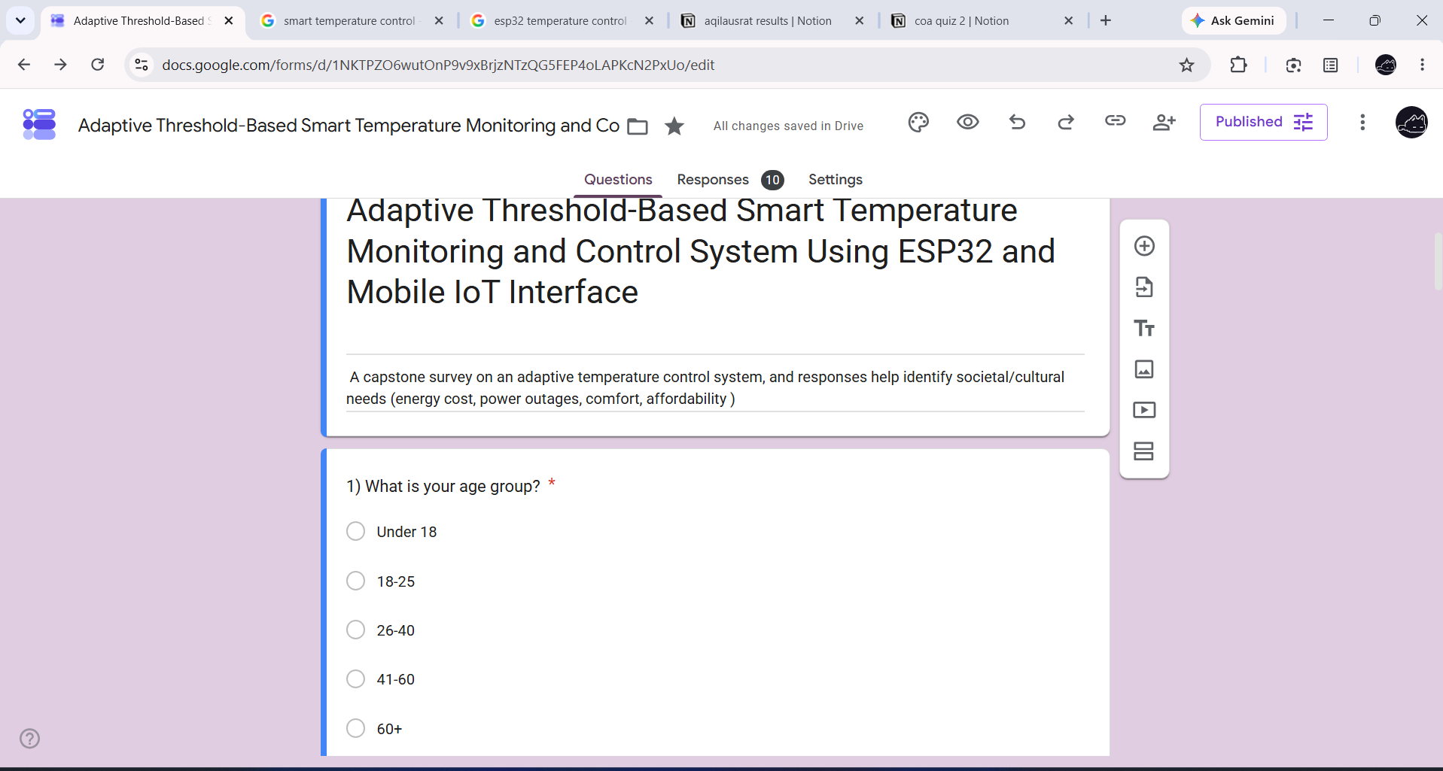

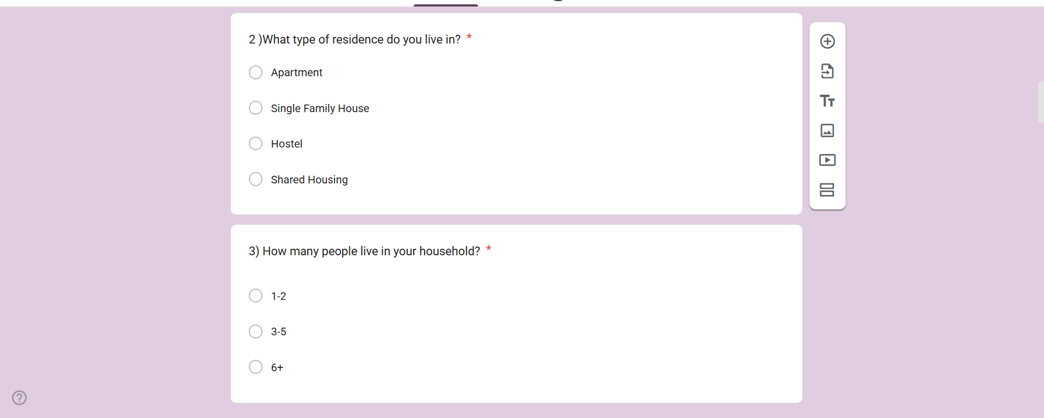

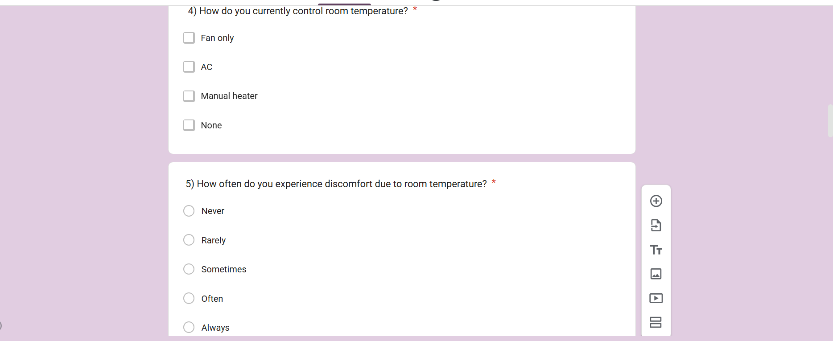

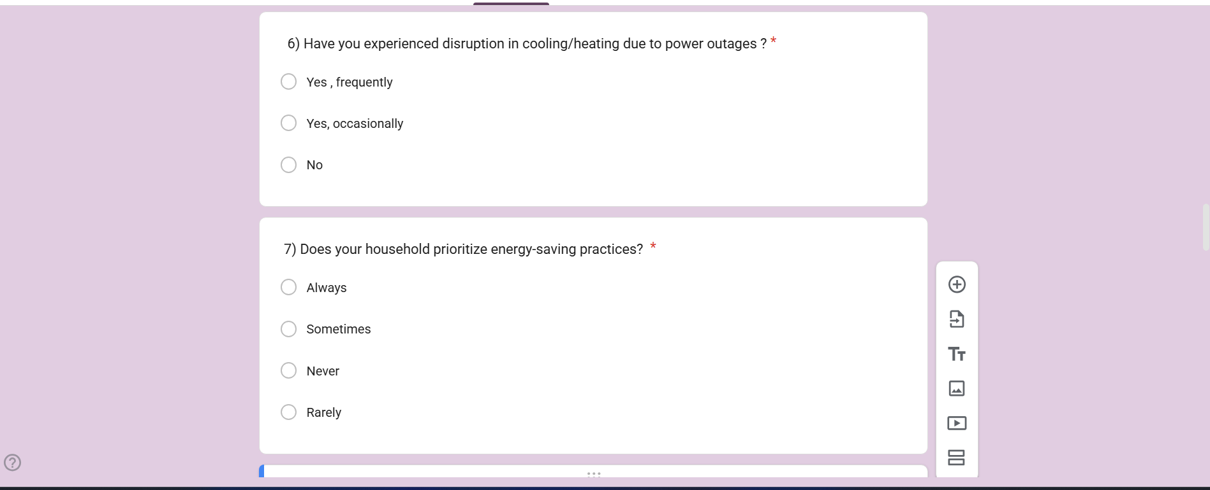

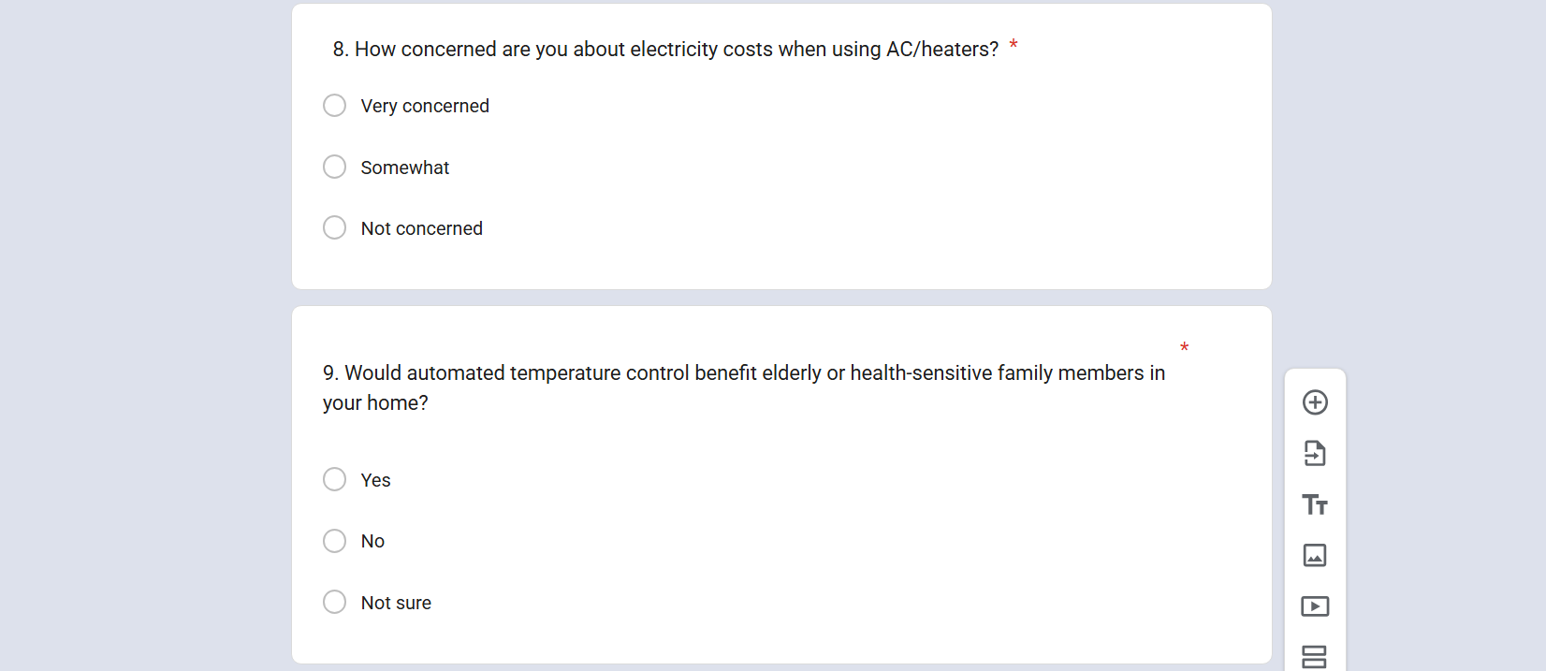

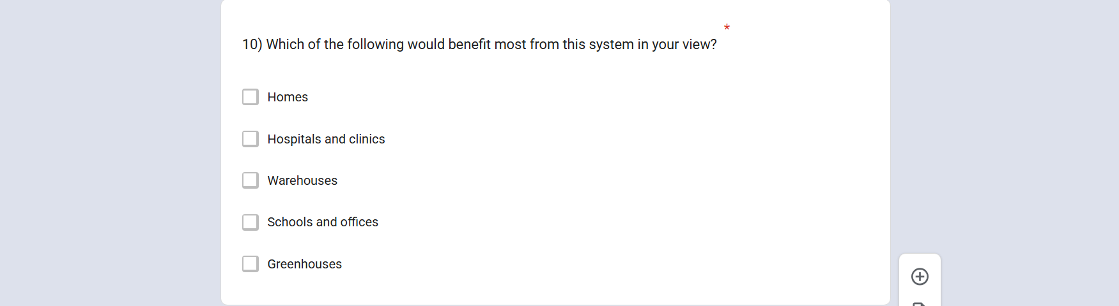

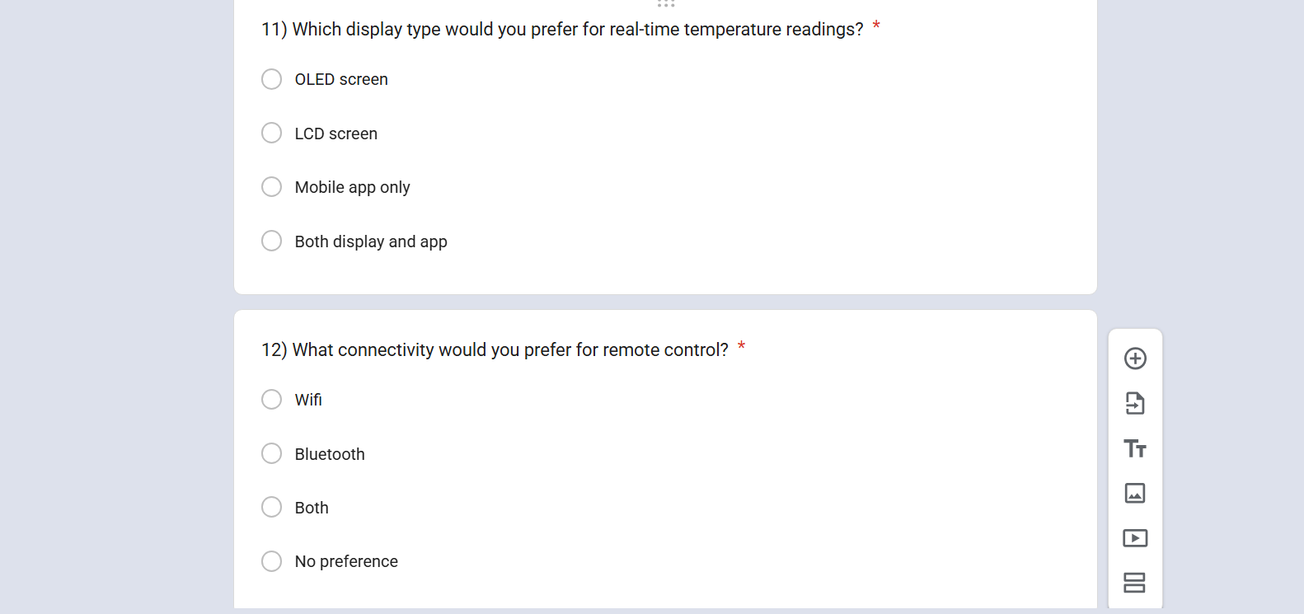

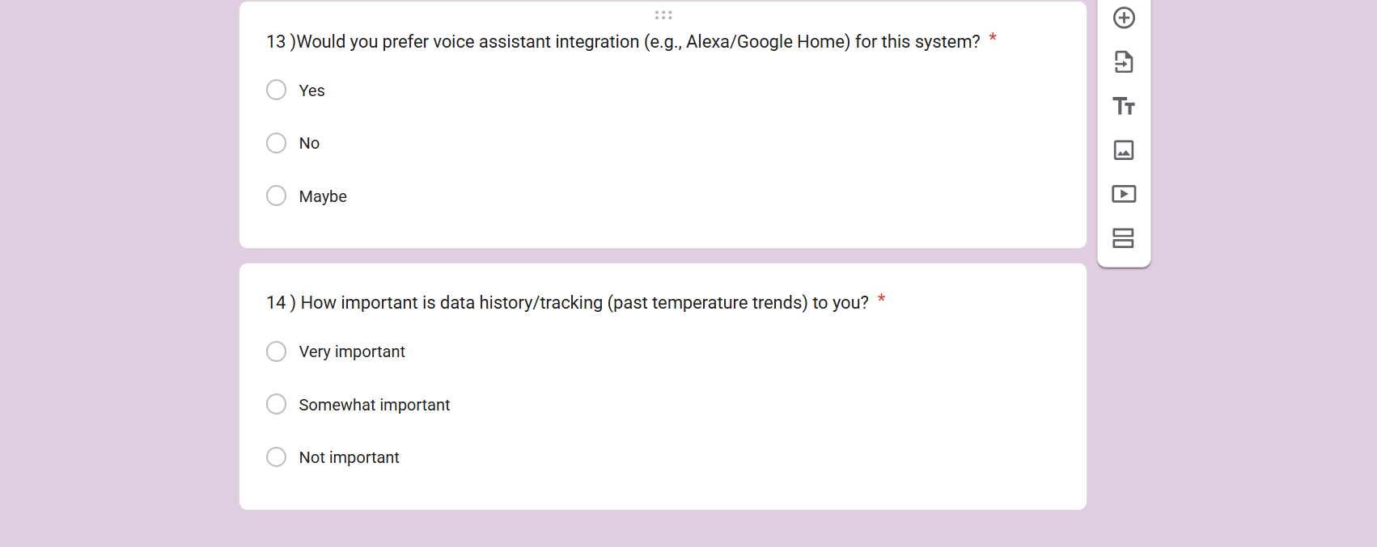

Outcomes :

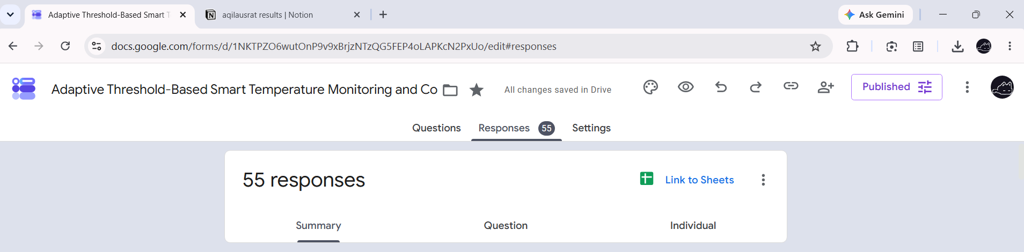

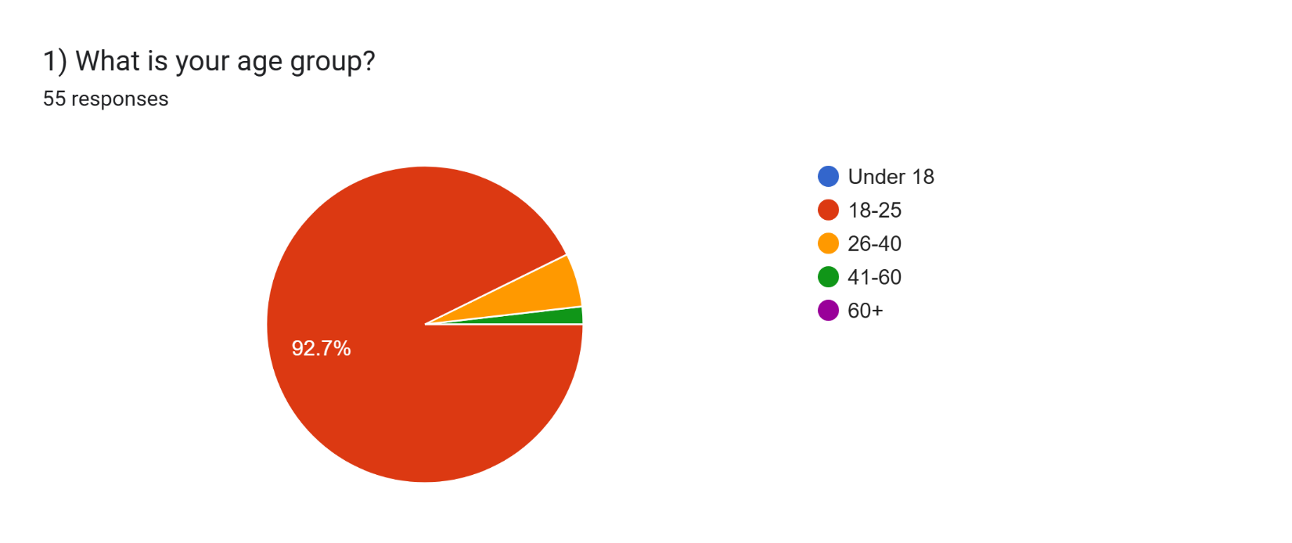
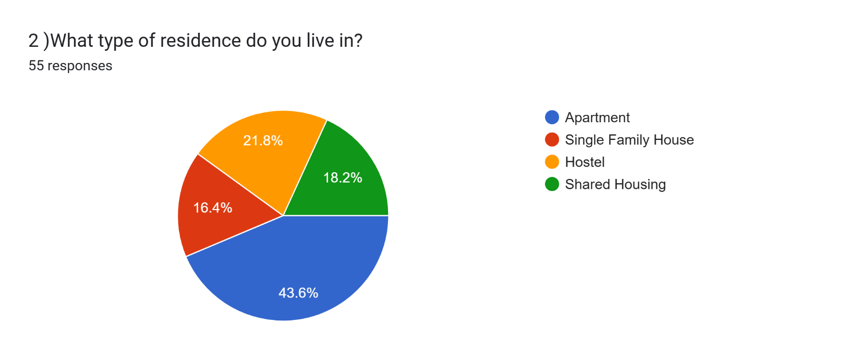

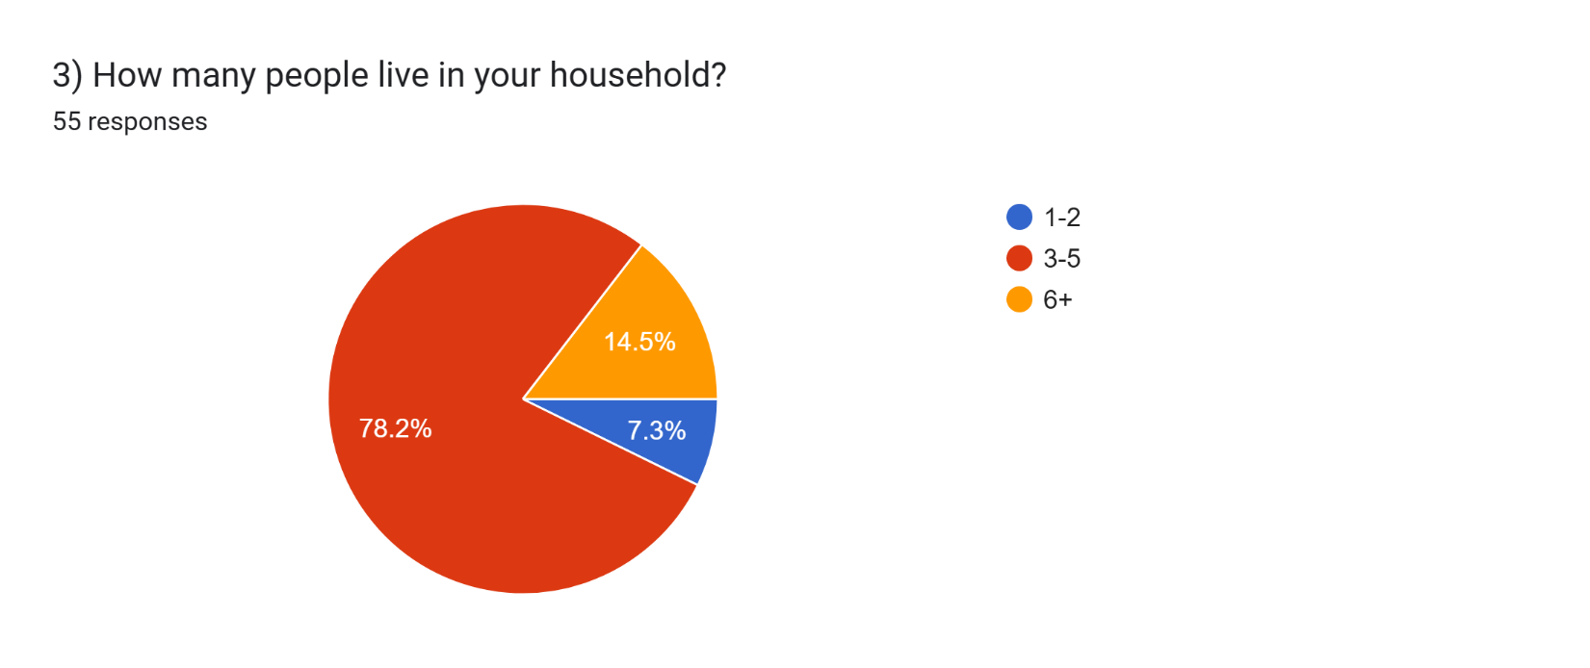

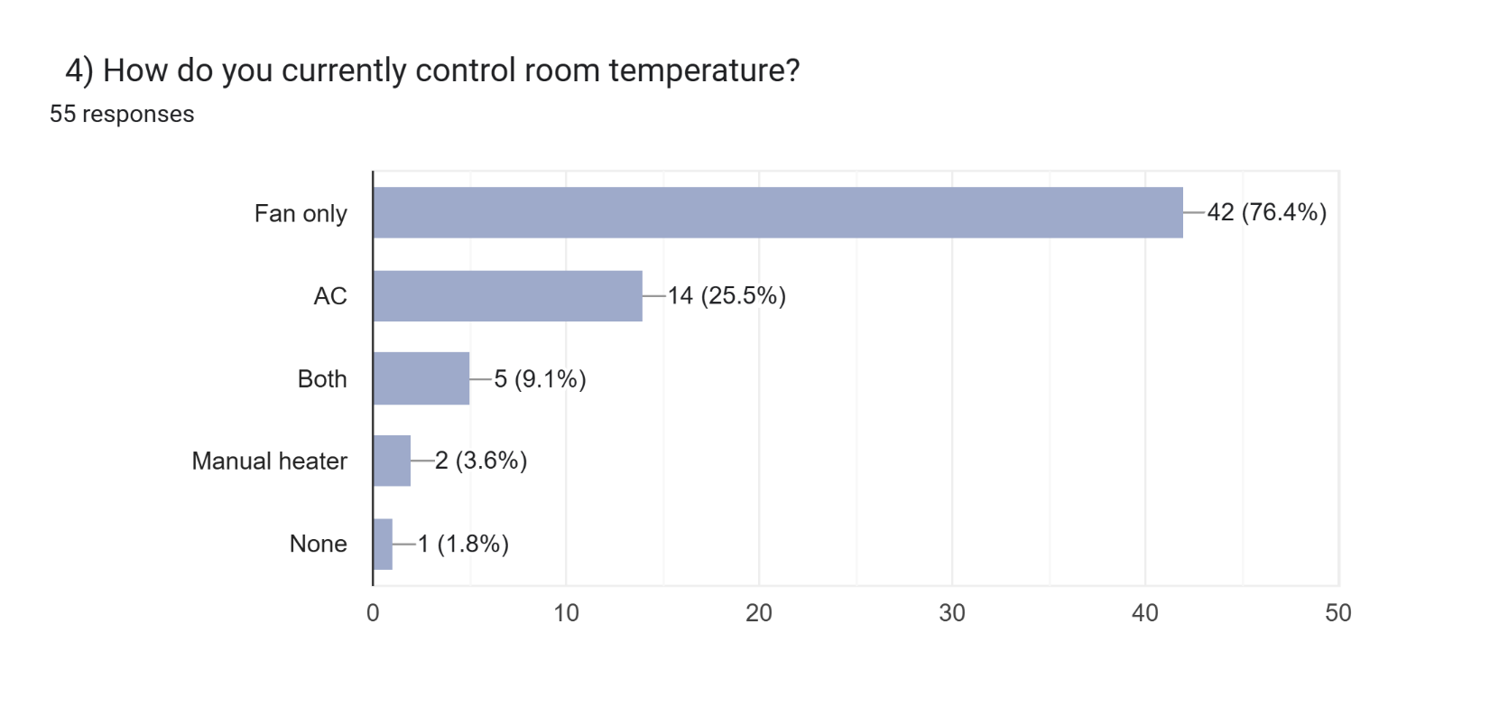

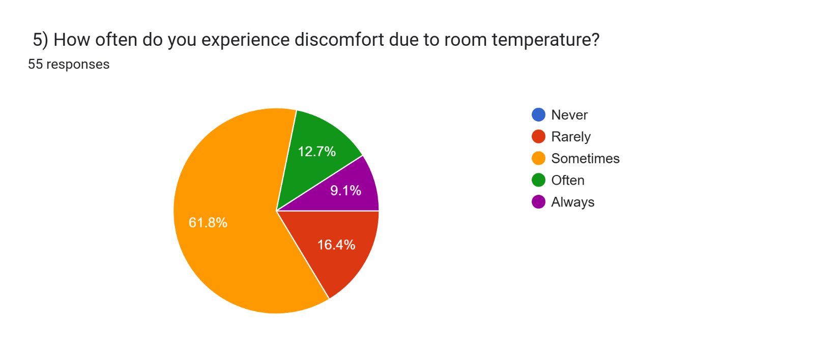
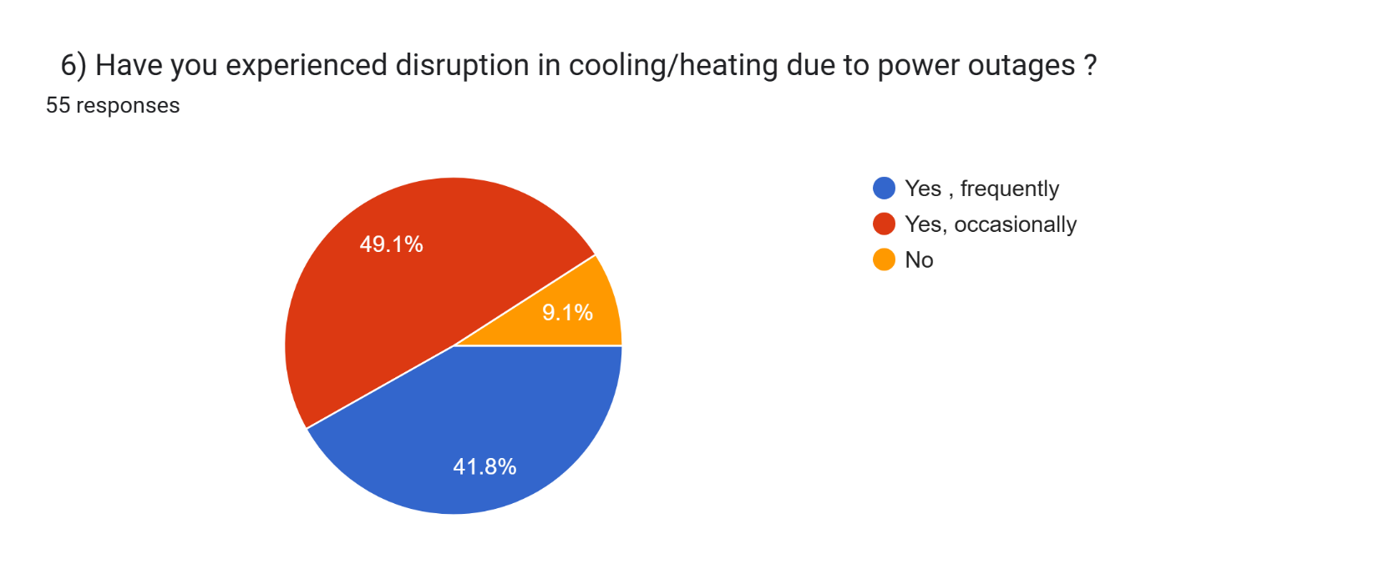

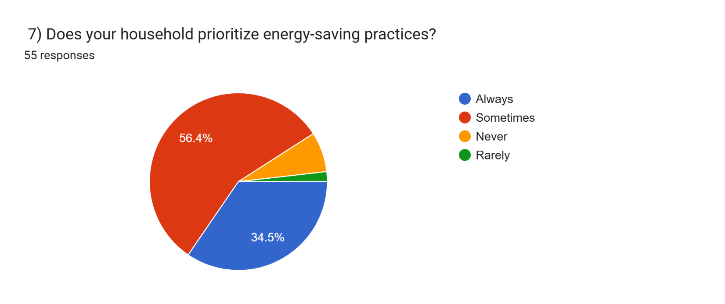

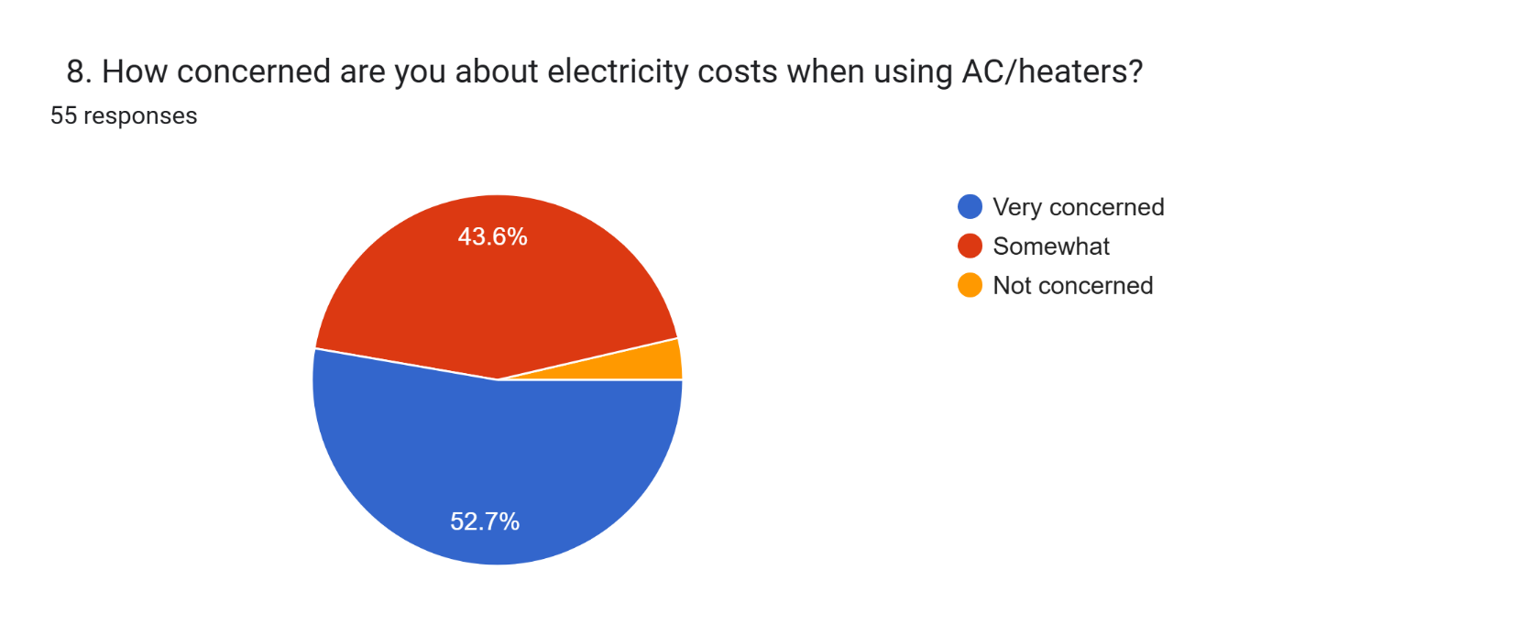

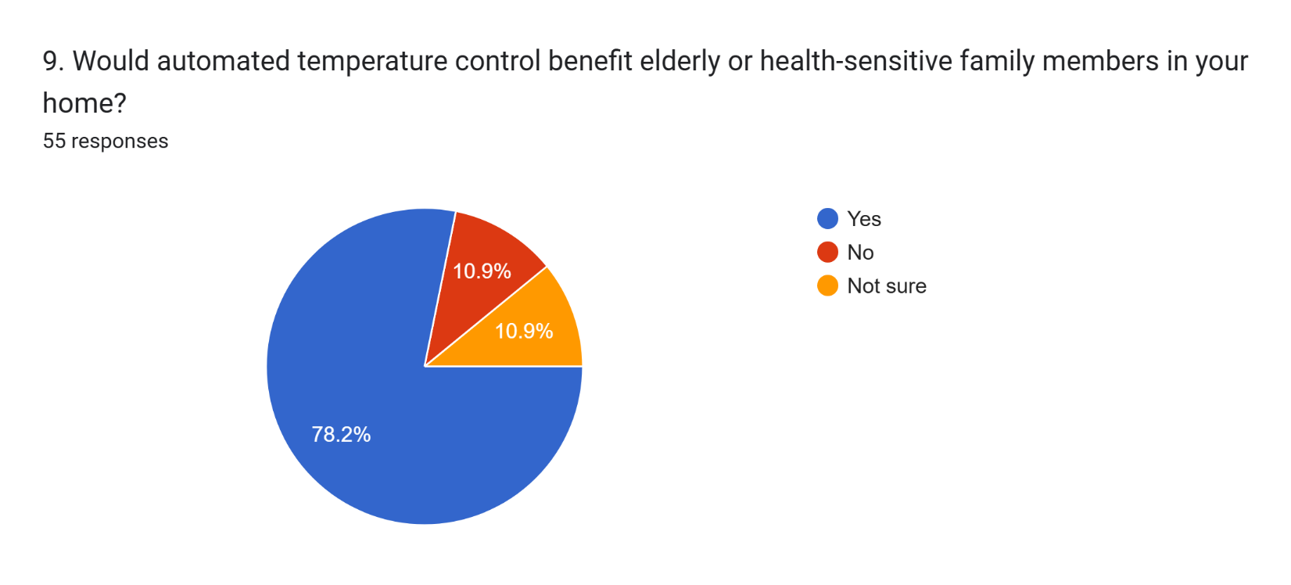

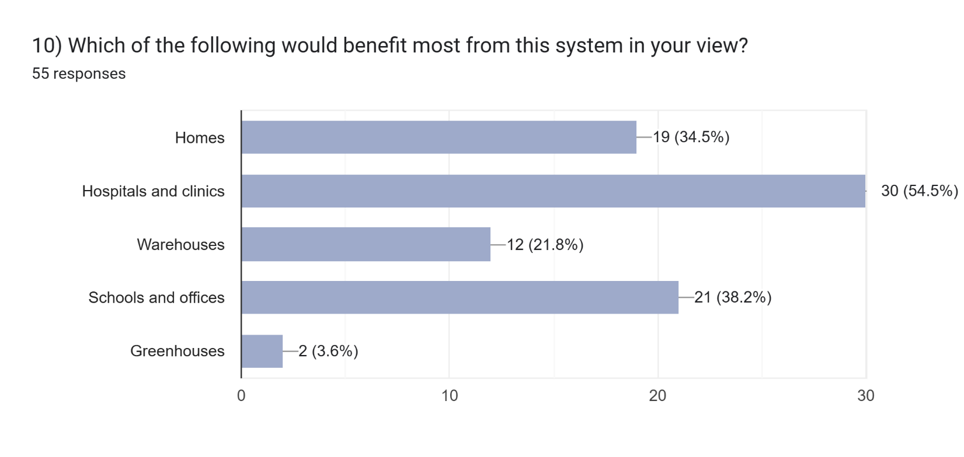

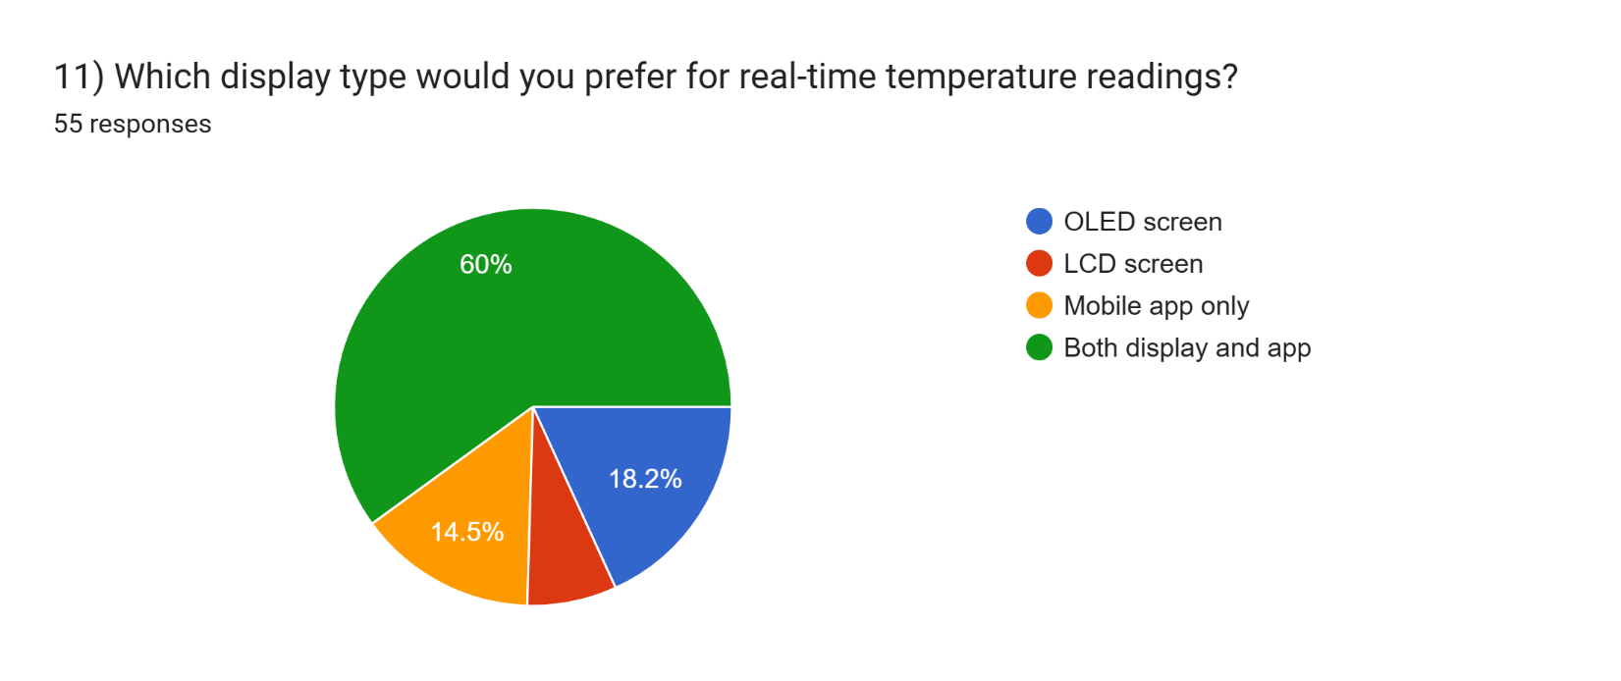

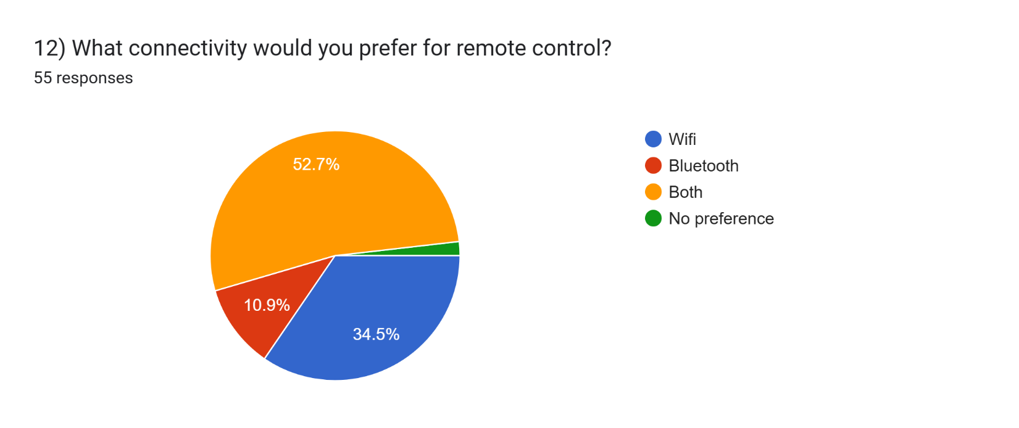

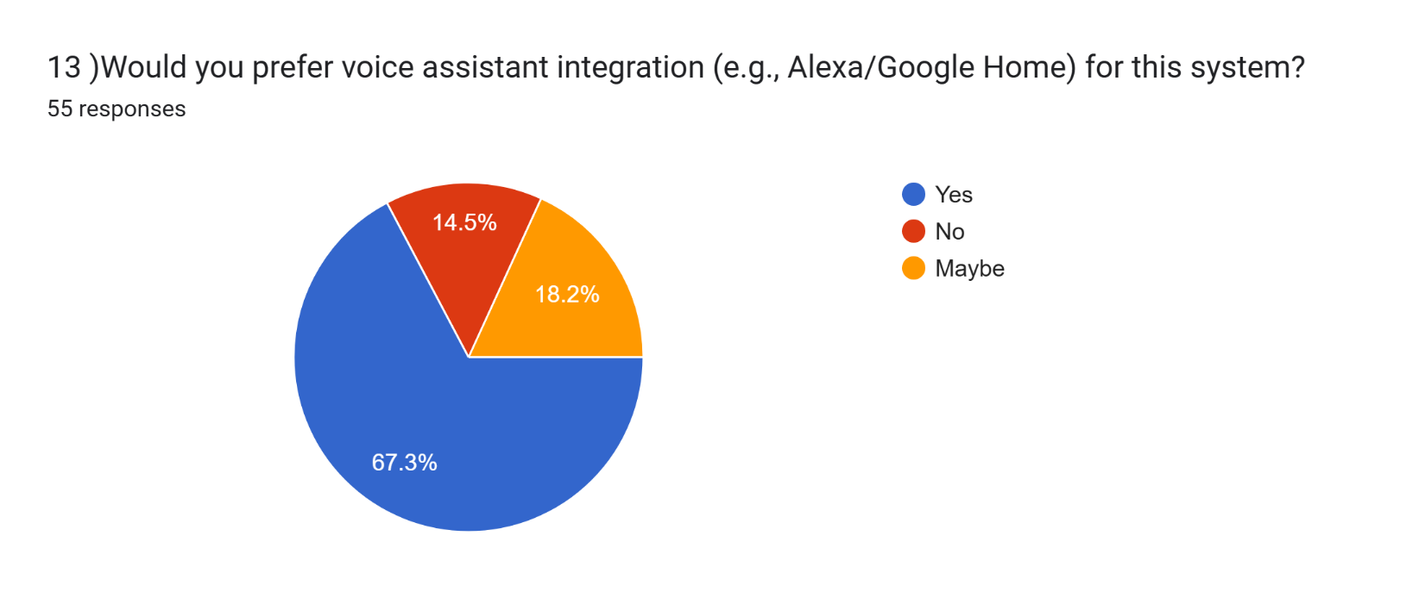

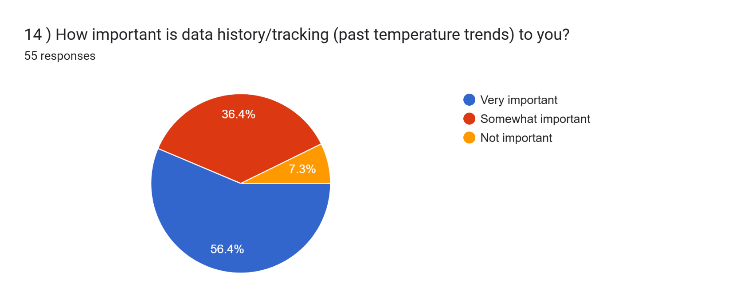

AIMS AND OBJECTIVES OF THE PROJECT:

- Design : an embedded hardware system using the ESP32 microcontroller, integrating a DHT11 temperature sensor, relay-controlled fan and heater units, and an OLED display for real-time temperature sensing and local visual feedback.
- Implement : an adaptive hysteresis-based control algorithm that introduces a buffer zone around the user-defined temperature thresholds, minimizing unnecessary and rapid switching of the fan and heater compared to conventional fixed-threshold control methods.
- Develop : a mobile application interface, connected through the ESP32's WiFi module, allowing users to remotely configure temperature thresholds, monitor live readings, and manually override automated control when required.
- Evaluate : the performance of the proposed adaptive threshold system by comparing its switching frequency and response stability against a standard fixed-threshold implementation under similar test conditions.

LITERATURE REVIEW:
Several studies have investigated IoT-based temperature monitoring and control for embedded systems. Marques et al. [2] proposed a smart room framework for ambient assisted living using multi-sensor IoT integration, achieving effective environmental monitoring, but without an accompanying automated control mechanism. Similarly, Daniela et al. [3] presented an IoT-based system for monitoring humidity and temperature in boarding house spaces, demonstrating reliable remote data acquisition; however, the system was restricted to passive monitoring with no actuation capability. A comparable limitation is observed in Budijono and Felita [9], where an ESP32 and DS18B20-based system was developed for continuous freezer temperature monitoring and preventive maintenance logging, but again lacked any closed-loop control response.
In contrast, several works have incorporated basic actuation for temperature regulation. Resquites et al. [1] developed an ESP32-based system for automatic fan control, though the authors note that adaptive fan speed management remains unaddressed and is proposed as future work. Sulaiman and Hidayat [4] implemented an Arduino-based fan control system governed by fixed minimum and maximum thresholds, a configuration prone to frequent switching near the set point. This limitation persists in more recent designs: Sinaga et al. [5] extended control to ventilation and lighting in a smart room system but retained conventional fixed-threshold logic, while Azmi et al. [6] applied multi-level PWM-based fan regulation using predefined thresholds, without adaptive behavior or network connectivity. Harianto et al. [7] developed a temperature and humidity control unit for textile storage, validated through black-box testing, but explicitly identify wireless remote monitoring as future work, and Ehiagwina et al. [8] achieved responsive real-time fan regulation without incorporating adaptive or remotely configurable thresholds.
Taken together, these studies reveal three recurring limitations in existing embedded temperature control systems: the absence of integrated actuation in monitoring-focused designs, the reliance on static thresholds that induce unnecessary switching in control-focused designs, and the limited availability of mobile-based remote configurability across both categories. Motivated by these gaps, this project proposes an ESP32-based smart temperature monitoring and control system that implements an adaptive hysteresis-based threshold algorithm, integrated with a dedicated mobile application for real-time monitoring and remote threshold adjustment.

EXPERIMENTAL BLOCK DIAGRAM:

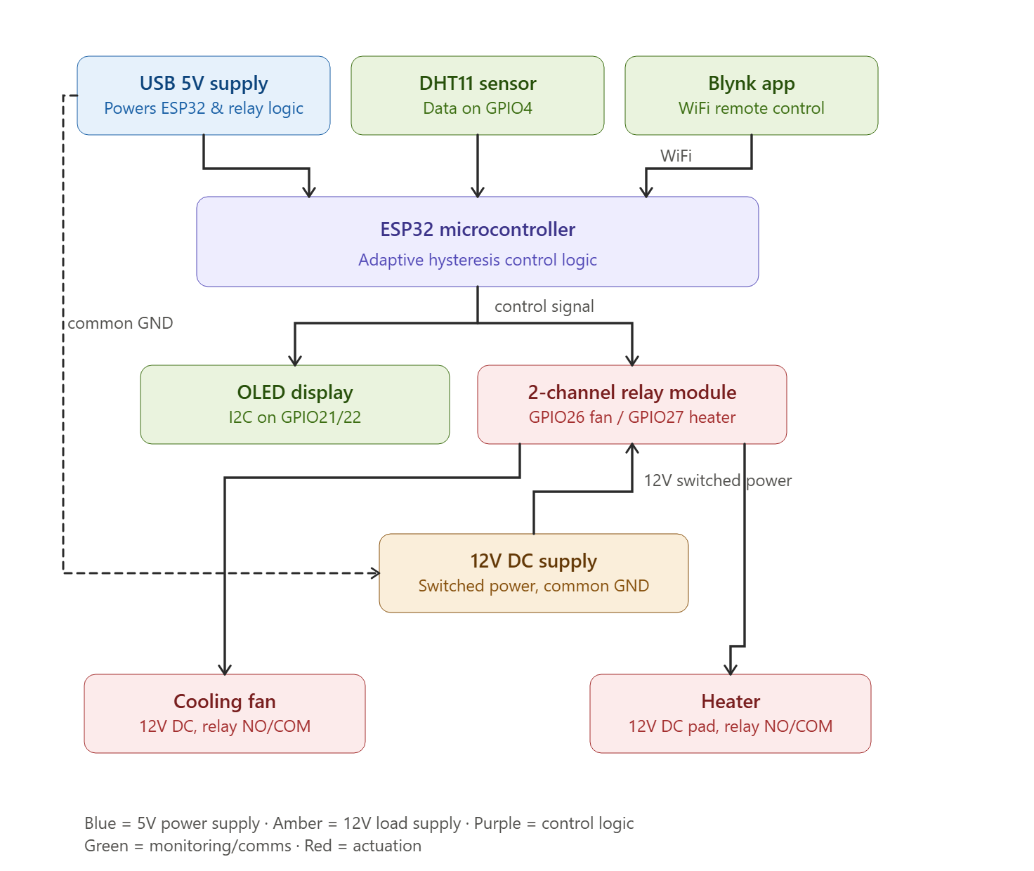

POSSIBLE OUTCOMES OF THE PROJECT:
- Reduced Unnecessary Electricity Consumption : By replacing manual, habit-based switching of fans and heaters with automatic, adaptive control, the system minimizes energy waste. This is especially relevant in a context where load-shedding and rising electricity costs make energy efficiency a shared societal concern.
- Accessibility Across Income Groups : Keeping the system low-cost allows it to be adopted not only by those who can afford advanced automation, but also by middle- and lower-income households, hostels, and small shops, broadening its practical reach.
- Improved Comfort and Health Outcomes : Stable, adaptive temperature control reduces abrupt fluctuations, benefiting elderly individuals and others sensitive to temperature changes .
- Remote Monitoring for Safety and Protection :The mobile-app alert feature enables elderly or working residents to remotely monitor conditions, helping safeguard vulnerable family members as well as temperature-sensitive items such as stored medicine or lab/server equipment.
- Enhanced Reliability During Power Disruptions :The lightweight, IoT-based architecture allows the system to respond efficiently even under unstable power conditions, offering more consistent performance in regions affected by frequent load-shedding.
- Applicability Beyond Residential Use : The system's design allows for adaptation to other environments such as hospitals, greenhouses, warehouses, and schools, extending its practical value beyond a single household setting.
PROJECT TIMELINE (GANTT CHART):
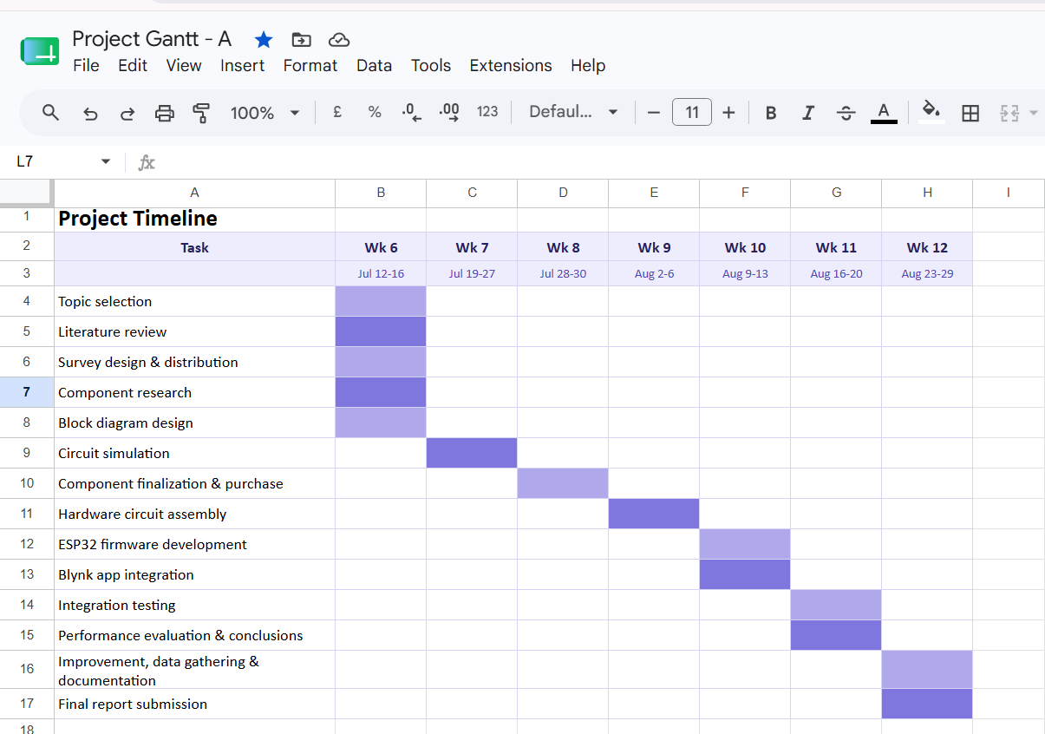
REFERENCES:

[1] J. C. M. Resquites, M. A. Parrocho, N. Vinegas, and V. H. Oquiño, "IoT-Based Temperature Monitoring and Automatic Fan Control Using ESP32," Iconic Research and Engineering Journals, vol. 7, no. 5, pp. 35–44, 2023.
🔗 https://www.irejournals.com/paper-details/1705183
[2] G. Marques, R. Pitarma, and C. Ferreira, "Smart room for ambient assisted living using IoT," Sensors, vol. 19, no. 3, 2019, doi: 10.3390/s19030663.
https://doi.org/10.3390/s19030663
[3] W. Daniela, A. Pramono, J. F. Wijaya, and N. P. Wijaya, "Integrating IoT-based devices for monitoring humidity and temperature in boarding house spaces," Procedia Computer Science, vol. 221, pp. 518–525, 2023, doi: 10.1016/j.procs.2023.10.518.
https://doi.org/10.1016/j.procs.2023.10.518
[4] M. F. Sulaiman and A. R. Hidayat, "Automatic fan control system using Arduino and temperature sensor," Int. J. Advanced Science, Engineering and Information Technology, vol. 10, no. 2, pp. 632–637, 2020, doi: 10.18517/ijaseit.10.2.11242.
https://doi.org/10.18517/ijaseit.10.2.11242
[5] D. Sinaga, D. B. Sirait, K. K. Pakpahan, M. Sihombing, and H. Hutauruk, "Design and Implementation of an ESP32-Based IoT Smart Room System with Automated Temperature, Ventilation, and Lighting Control," Journal of Intelligent Systems, Embedded Systems, and Computer Engineering, vol. 1, no. 1, pp. 1–11, 2026, doi: 10.65358/rva03t27.
https://jisece.com/jisece/article/view/2
[6] F. N. Azmi, M. R. R. Putra, M. I. Darmanto, G. Warino, and P. Wulandari, "Temperature-Responsive DC Fan Control System Using ESP32 and DHT22 for Improved Energy Efficiency," Seminar Nasional Teknik Elektro, vol. 4, no. 1, pp. 9–18, 2025, doi: 10.46962/snte.25.063.
https://snte.fortei.org/list/index.php/snte/article/view/63
[7] D. Harianto, H. S. Bintang, A. Ardiyanto, and V. L. D. Widyawan, "Development and Evaluation of an ESP32-based Temperature and Humidity Control Unit for Textile Storage," International Journal of Engineering Continuity, vol. 4, no. 1, pp. 1–19, 2024, doi: 10.58291/ijec.v4i1.309.
https://ejournal.sultanpublisher.com/index.php/ijec/article/view/309
[8] F. O. Ehiagwina, H. J. Onawola, T. I. Akhuetie, and K. O. Raheem, "Automated Fan Regulation using Real-Time Temperature Monitoring," Journal of Innovations in Engineering and Technology Research, vol. 8, no. 5, 2025.
https://www.researchgate.net/publication/392905893
[9] S. Budijono and Felita, "Smart Temperature Monitoring System Using ESP32 and DS18B20," IOP Conf. Ser.: Earth Environ. Sci., vol. 794, no. 1, p. 012125, 2021, doi: 10.1088/1755-1315/794/1/012125.
https://www.researchgate.net/publication/353649934

Instructions:
- There is no definite format for writing the course project proposal, but students must follow the instructions mentioned above properly.
- Fill in the form accurately with all necessary information.
- Make a color print on this form.
- Figures, tables, charts, circuit diagrams, block diagrams, and wave shapes must be color printed.
- The survey form links with the answers that must be provided in the proposal form.

FOR FACULTY USE ONLY
COMMENTS BY COURSE TEACHER:

COURSE TEACHER’S NAME Md. Rukonuzzaman COURSE TEACHER’S SIGNATURE DATE

NAME: Aqila Usrat  ID: 23-54501-3  PROGRAM: CSE  EMAIL: 23-54501-3@student.aiub.edu | NAME: Lubaba Zannatul Haque  ID : 24-58779-2  PROGRAM: CSE  EMAIL: 24-58779-2@student.aiub.edu
NAME: Md. Al- Moon Kayes  ID : 23-54925-3  PROGRAM: CSE  EMAIL: 23-54925-3 @student.aiub.edu | NAME: Faddilah Islam  ID: 24-58650-2  PROGRAM: CSE  EMAIL: 24-58650-2@student.aiub.edu
NAME: Sanzana Afroze Zarin  ID : 24-59483-3  PROGRAM: CSE  EMAIL: 24-59483-3@student.aiub.edu | NAME: ………………………………………………  ID #:………………………………  PROGRAM: EEE/CoE/CSE  EMAIL:

Assessment Materials and Marks Allocation:
CO | Assessment Materials | POIs | Marks
CO2 | Course Capstone Proposal Form | P.c.2.C6  P.c.3.C5 | 50

Course Name: |  | Microprocessor and Embedded Systems Lab | Course Code: | EEE 4103
Semester: |  | Summer 2025-26 | Sec: | O
Faculty Member: |  | Md. Rukonuzzaman
Capstone Project Title: |  | Design and Implementation of an Adaptive Threshold-Based Smart Temperature Monitoring and Control System Using ESP32 with a Mobile IoT Interface
Project Group No. |  | 07
Sl # | Student ID # | Student Name | Obtained Marks
1. | 23-54501-3 | Aqila Usrat
2. | 24-58779-2 | Lubaba Zannatul Haque
3. | 24-59483-3 | Sanzana Afroze Zarin
4. | 24-58650-2 | Faddilah Islam
5. | 23-54925-3 | Md. Al- Moon Kayes
6.

Assessed POI:
CO/  CLO Number | CO/CLO Statement | K | P | A | Assessed Program Outcome Indicator | BNQF Indicator | Teaching-Learning Strategy | Assessment Strategy
2 | Develop a survey to implement a capstone project considering cultural and societal concerns. | K5 | P1,  P2-3  P6-7 |  | P.c.2.C6  P.c.3.C5 | PS.2 | Discussion | Course Project Proposal Form

Assessment Rubrics:
KPIs | Excellent  [2] | Proficient  [1.5] | Good  [1] | Acceptable  [0.5] | Unacceptable  [0] | No Response  [0] | Secured Marks
Project Title | The title reflects an issue related to complex engineering problems, showing targets and methods with possible outcomes. | The title reflects an issue related to complex engineering problems, showing targets and methods, but some missing issues. | The title reflects an issue related to the course capstone project, but there may be some missing issues. | The title reflects an issue related to the course capstone project, but it is not complete or specific. | The title does not reflect any issues related to the course capstone project. | No Response at all/ copied from others /identical submissions with gross errors/ image file printed
Comments |  |  |  |  |  | Total Marks (2)

KPIs | Excellent  [10-12] | Proficient  [7-9] | Good  [4-6] | Acceptable  [2-3] | Unacceptable  [1] | No Response  [0] | Secured Marks
Survey | The survey developed as a process for complex engineering problems, considering cultural and societal factors, has superior variables, targets, measures, and the implementation process is clear and challenging for future project implementation, with several possible outcomes having good impacts. | The survey, developed as a process for complex engineering problems, considering cultural and societal factors, has good variables, targets, measures, and the implementation process is clear and challenging for future project implementation, with some possible outcomes and little impact. | The survey developed as a process for complex engineering problems, considering cultural and societal factors, has moderate variables, targets, measures, and  The implementation process is clear and challenging for future project implementation, with a few possible outcomes and impacts. | The survey, developed as a process for complex engineering problems, considering cultural and societal factors, has good variables, targets, measures, and the implementation process is somewhat clear for future project implementation, with very few possible outcomes and little impact. | The survey developed as a process for complex engineering problems, considering cultural and societal factors, has poor variables, targets, measures, and  the implementation process is very unclear for future project implementation, with few possible outcomes but no impacts. | No Response at all/ copied from others /identical submissions with gross errors/ image file printed
Comments |  |  |  |  |  | Total Marks (12)

KPIs | Excellent  [4] | Proficient  [3] | Good  [2] | Acceptable  [1] | Unacceptable  [0.5] | No Response  [0] | Secured Marks
Aims and Objectives | Aims and objectives are written to solve complex engineering problems, considering cultural and societal factors with specific targets, measurements, and implementation processes that are clear and challenging, and have several possible outcomes having very good impacts. | Aims and objectives are written to solve complex engineering problems, considering cultural and societal factors with general targets, measurement, and implementation processes that are not clear and challenging, and have some possible outcomes that have a good impact. | Aims and objectives are written to solve complex engineering problems considering a few cultural and societal factors with narrow targets; measurement, and implementation processes are clear and challenging and have a few possible outcomes, having some impacts. | Aims and objectives are written to solve complex engineering problems considering cultural or societal factors with a very specific target; measurement and implementation processes are not clear or challenging, and have little possible outcome, having no impact. | Aims and objectives are written to solve complex engineering problems, but do not consider cultural and societal factors with any targets; measurement and implementation processes are not clear and challenging, and no possible outcomes that have an impact. | No Response at all/ copied from others /identical submissions with gross errors/ image file printed
Comments |  |  |  |  |  | Total Marks (4)

KPIs | Excellent  [10-12] | Proficient  [7-9] | Good  [4-6] | Acceptable  [2-3] | Unacceptable  [1] | No Response  [0] | Secured Marks
Literature Review | Specific formats are maintained to review and cite the literature with recent publications. Identified and analyzed the problem correctly. | Specific formats are maintained to review and cite the literature with recent publications. Identified and analyzed the problem correctly, but not all issues were addressed with relevant or intended work. | Specific formats are maintained to review and cite the literature with recent and past publications. Identified and analyzed the problem correctly, but not all issues were addressed with relevant or intended work. | Specific formats are maintained to review and cite the literature with recent and past publications. Identified but could not analyze all the problems correctly, and all issues were not addressed with relevant or intended work. | No specific formats are maintained to review and cite the literature with recent publications. Could not identify and analyze all the problems correctly, and all issues are not addressed with relevant or intended work at all. | No Response at all/ copied from others/ identical submissions with gross errors/ image file printed
Comments |  |  |  |  |  | Total Marks (5)

KPIs | Excellent  [5-6] | Proficient  [4] | Good  [3] | Acceptable  [2] | Unacceptable  [1] | No Response  [0] | Secured Marks
Experimental Block Diagram | The block diagram is drawn to show the connections of all the possible components or subsystems to show their interdependence with all possible flows of signals from inputs to outputs. | The block diagram is drawn to show the connections of all of the possible components or sub-systems to show their interdependence, with a few missing flows of signals from inputs to outputs. | The block diagram is drawn to show the connections of most of the possible components or sub-systems to show their interdependence, with a few missing flows of signals from inputs to outputs. | The block diagram is drawn to show the connections of a few possible components or sub-systems to show their interdependence, with some missing flow of signals from inputs to outputs. | The block diagram is not drawn to show the connections of all possible components or sub-systems, to show their interdependence and flow of signals from inputs to outputs. | No Response at all/ copied from others /identical submissions with gross errors/ image file printed
Comments |  |  |  |  |  | Total Marks (5)

KPIs | Excellent  [4] | Proficient  [3] | Good  [2] | Acceptable  [1] | Unacceptable  [0.5] | No Response  [0] | Secured Marks
Possible Outcomes | Outcomes are written to achieve complex engineering problems’ solutions, considering cultural and societal factors and showing measurement and implementation processes to attain the outcomes with all possible impacts. | Outcomes are written to achieve complex engineering problems’ solutions, considering cultural and societal factors and showing measurement and implementation processes to attain the outcomes with some impacts. | Outcomes are written to achieve complex engineering problems’ solutions, considering cultural and societal factors, and do not show measurement and implementation processes to attain the outcomes without showing any impacts. | Outcomes are written to achieve complex engineering problems’ solutions, but do not consider cultural and societal factors, and do not show measurement and implementation processes to attain the outcomes without showing any impacts. | Outcomes are not written to achieve complex engineering problems’ solutions, do not consider cultural and societal factors, and do not show measurement and implementation processes to attain the outcomes without showing any impacts. | No Response at all/ copied from others /identical submissions with gross errors/ image file printed
Comments |  |  |  |  |  | Total Marks (4)

KPIs | Excellent  [6-7] | Proficient  [4-5] | Good  [3] | Acceptable  [2] | Unacceptable  [1] | No Response  [0] | Secured Marks
Gantt Chart | Specific formats are maintained to draw the Gantt chart, and there is an order of workflow with all work to be done. | Specific formats are maintained to draw the Gantt chart, and there is an order of workflow with a few tasks missing. | Specific formats are maintained to draw the Gantt chart, and there is an order of workflow with some work missing. | No specific formats are maintained to draw the Gantt chart, and there is little order to the workflow, with some work missing. | No specific formats are maintained to draw the Gantt chart, and there is no order of workflow, with the most important tasks missing. | No Response at all/ copied from others/ identical submissions with gross errors/ image file printed
Comments |  |  |  |  |  | Total Marks (5)

KPIs | Excellent  [3] | Proficient  [2.5] | Good  [2] | Acceptable  [1] | Unacceptable  [0.5] | No Response  [0] | Secured Marks
References | Specific formats are maintained to write references, and all are recently published journal and conference papers having no missing information. | Specific formats are maintained to write the references, and all are journal and conference papers, but some old papers have missing information. | No specific formats are maintained to write the references, and many are internet sources with several missing information and very old references. | No specific formats are maintained to write the references, and most of them are internet sources with missing information. | No specific formats are maintained to write the references, and all are internet sources with missing information. | No Response at all/ copied from others /identical submissions with gross errors/ image file printed
Comments |  |  |  |  |  | Total Marks (3)

